**URUVS Video Analysis –** last updated 19/03/2024 sw

1. DATASHEET

Video Files will look like this:

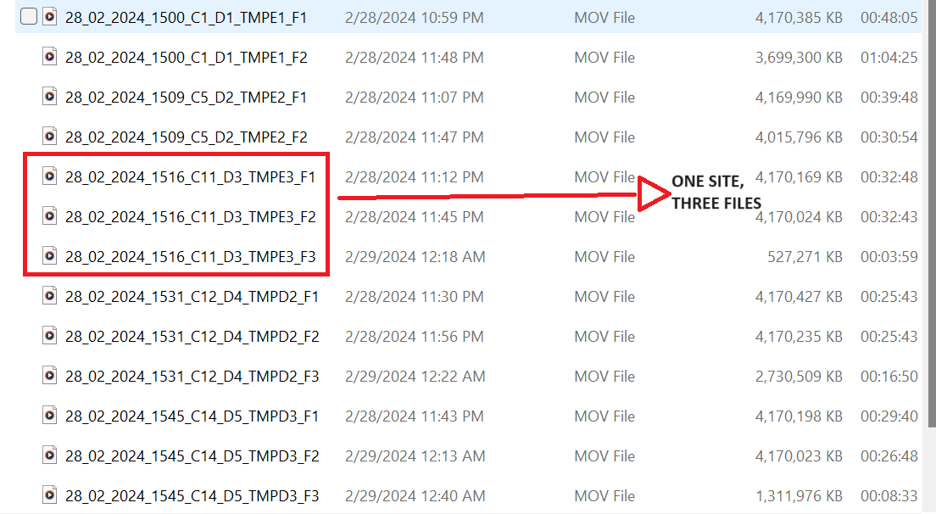

Videos from the camera are saved in 1-3 files. Files with the same name are the same video, just split up. Videos are named like this:

19_02_2024_1524_B1_D1_SiteName_F1

* + DATE: DD_MM_YYYY
  + TIME OF CAMERA DEPLOYMENT (MILITARY)
  + CAMERA NUMBER
  + DEPLOYMENT NUMBER
  + NAME OF SITE
  + FILE NUMBER

The Datasheet will look like this with explanations of each box below. Fill in all the blue boxes before starting analysis

File name: 19_02_2024_1524_B1_D1_SiteName_F1

|  |  |  |  |
| --- | --- | --- | --- |
| **SITE:** SiteName | **DATE:** | **CAM/DROP:** B1_D1 | **#FILES:** FROM FOLDER. NUMBER OF FILES MADE BY EACH RECORDING |
| **TOTAL TIME** EACH FILE | **F1:** | **F2:** | **F3:** |
| **TIME USED** Time used in Analysis | **TIME START:** UNUSED TIME IN F1 | **TIME END:** UNUSED TIME IN FINAL FILE. NOTE WHICH FILE. |  |
| **VISIBILITY:** FROM CALIBRATION STICK | **VEGITATION:** % SCREEN COVERED BY VEGITATION | **DATE ANALYZED:** Date analyzed and initials | **UPLOADED TO DRIVE?** |
| **FISH FOUND:**  RECORD:   * T1 each species * MaxN each species * Questions and fish to ask about – MAKE SURE TO INCLUDE WHICH FILE * If a recording was taken NOTE WHICH FILE AND TIME OF RECORDING | | | |

**SITE:** Name of site where data was taken. Will be found in file name. Site names are formatted as DESA NAME (Tompotana or Lantampeo) MANGROVE TYPE (L = Lush, E = Restored, D = Degraded), SITE # (1-6). Example: TMPE6

**DATE:** Date in the format dd_mm_yyyy. Will be found in file name

**CAM/DROP:** Camera number used/Number of deployment of the day. Will be found in file name.

**#FILES:** The total number of files created by each recording. Typically 1-3.

**TOTALTIME:** Record the total time of each file. Example: F1: 0:42:13 | F2: 0:33:00 | F3: 0:13:38. Make sure to put hours:minutes:seconds

**TIME USED:** You won’t be analyzing the whole video. We often kick up a lot of dirt or scare all the fish away. Watch the video until we set the calibration stick and walk away, then skip five minutes after that point. If the video is clear, start analysis at that time. If the video is not clear, skip five more minutes and see if better. You don’t want to go more than 15 minutes because our **goal is to get about 1 hour of analyzed time** (it’s okay if it’s a little bit more or less, but 1 hour is our goal).

The battery often dies before we pick up the camera. If that’s the case, use the video until the end. If you can see us pick up the camera, back up five minutes from that point and note that as the end time **make sure to note which file number you used for the end time,** sometimes the third file isn’t usable so we just use the first two files.

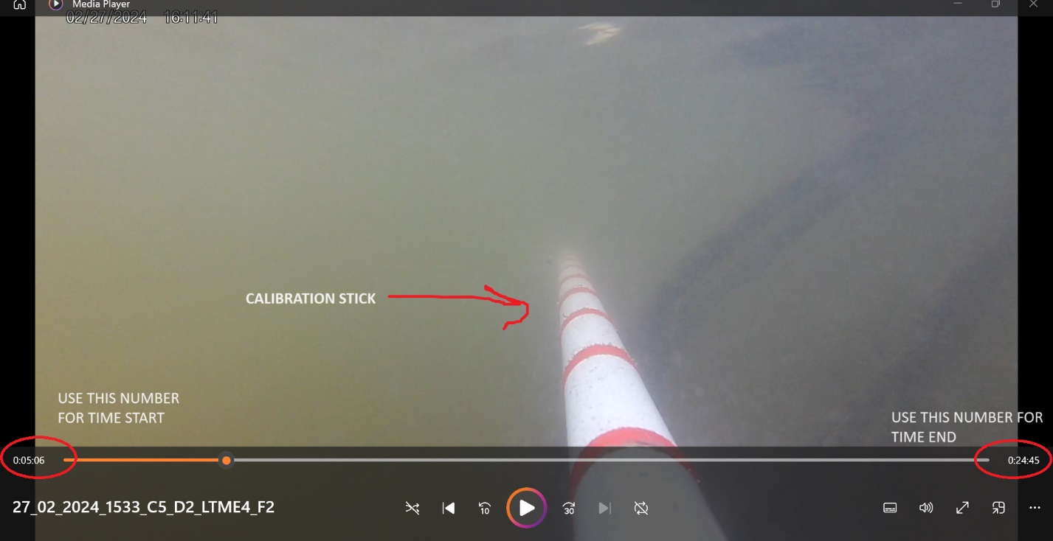

Note: We want to write down the amount of UNUSED time in the video, so when recording TIME START, record the time that has already passed (left) and when recording TIME END, record the time that won’t be used (right)

**VISIBILITY:** Different videos will have different amounts of visibility based on light, plants, and water clarity. Count the number of red rings you see on the calibration stick (image above) and multiply by 10 (each ring is 10 cm apart).

**VEGITATION:** Visually estimate the amount of screen that is taken up by vegetation. Example above, I would say about 25%. It’s okay to not be perfect, just an estimation.

**DATA ANALYZED:** The date you analyzed the video **and your initials**. In case I have a question, this lets me know who to ask 😊

**UPLOADED TO DRIVE:** You can ignore this, I back up every video in my google drive so this is recording which has already been uploaded

1. VIDEO ANALYSIS

In the **FISH FOUND** box in the above data sheet, that’s where you’ll put your observations.

**For each species**, record:

* T1 – The first time you see this species on screen. Use the bottom left time and note the file which it came from
* MAXN – The maximum number of that species on screen at a time. You don’t need to record EVERY occurrence, but just the maximum. Still note the time and file number
* Questions you may have
* If you take a recording, note the time the recording was taken, and the name of the recording file. Sometimes the first time you see a species isn’t the best shot

Some fish will be too blurry or small to know the species. That’s okay, just write UNIDFISH or UNIDGUPPY (if it looks like baby) as the species name and record T1 and MAXN.

**Right now, there will be a lot of unnamed fish (and that’s okay) so we want to create a bank of fish to identify later. That’s why we have that shared SPECIES Qs folder. For now, we can just name things FISHA or GUPPYA (if it looks like a juvenile fish). Juvenile fish are extremely hard to ID so we’ll do our best. We can get together regularly so we can be on the same page about species.**

1. CRABS, SNAKES, UNKNOWN FISH, COOL STUFF

We’re going to treat these a little differently. Please note every time you see a crab, and if you have time, try to ID if it’s a mud crab or a swimmer crab. Same with snakes. Take a video of either of these if they look cool.

EVERYBODY LOVES A COOL FISH So if there’s a really cool shot of a fish, go ahead and take a recording too and send it to me (please note file name and time clip was taken). These are great visuals for the community to see as well, so they know their mangrove restoration efforts are working.

MAKE SURE IT SAYS IN THE DATASHEET THAT YOU TOOK A CLIP AND NOTE THE TIME THE CLIP IS TAKEN FROM